Assignment 18.1

Below is the dataset which we will be using for this Assignment in all problems. It has been kept in local file system:-
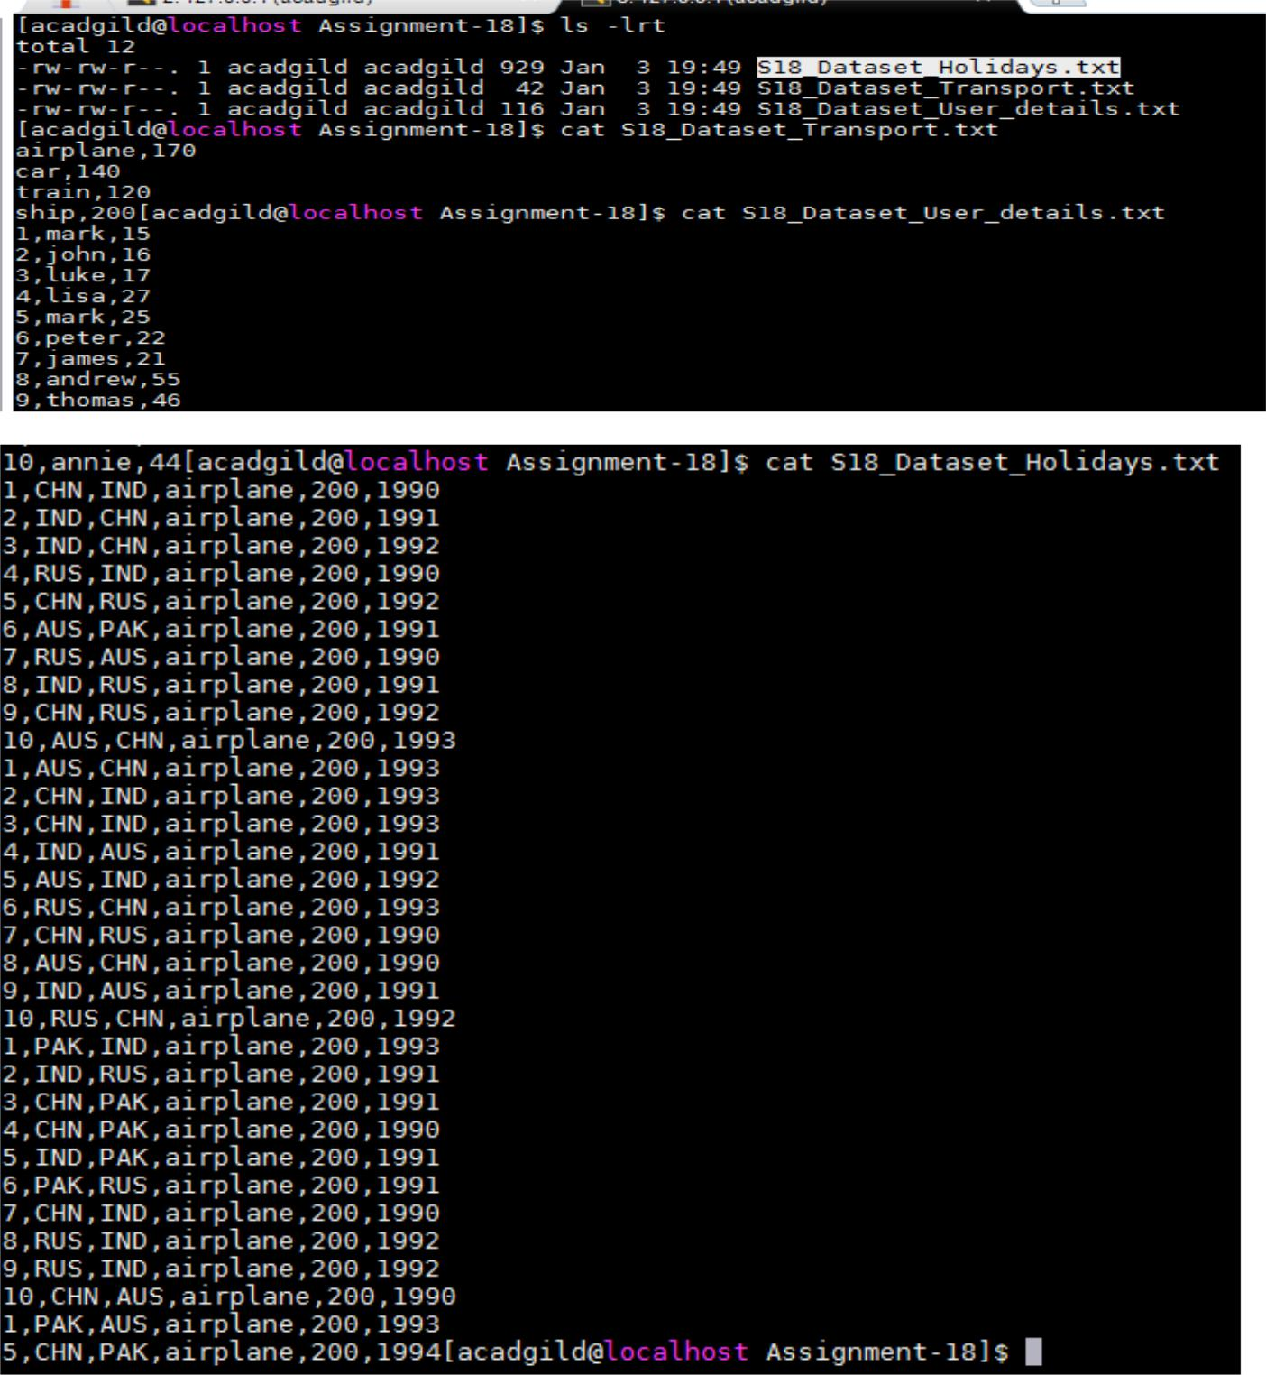
DataSet is uploaded in baseRDD:-

- val baseRDD = sc.textFile("/home/acadgild/Assignment-18/S18_Dataset_Holidays.txt")

- import org.apache.spark.storage.StorageLevel

- baseRDD.persist(StorageLevel.MEMORY_ONLY)
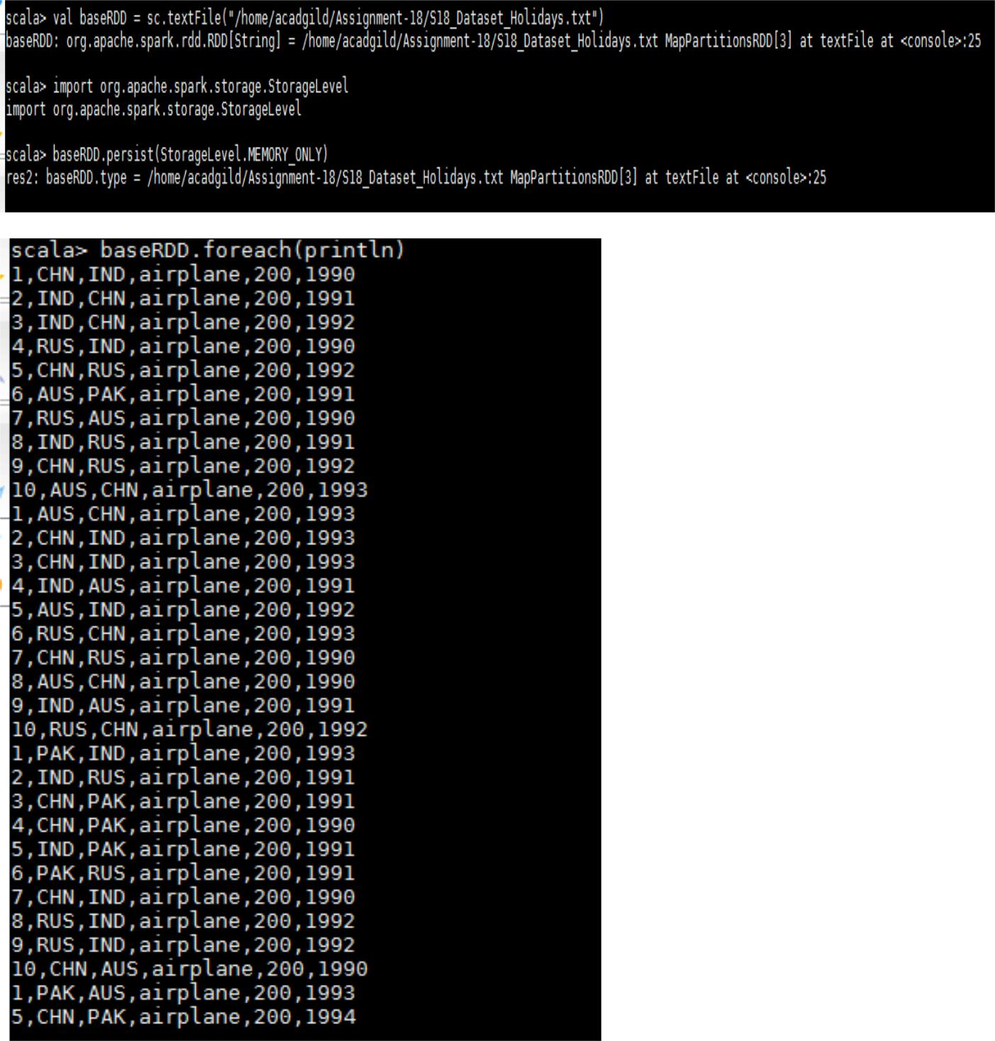
Problem Statement:-

- What is the distribution of the total number of air-travelers per year

- What is the total air distance covered by each user per year

- Which user has travelled the largest distance till date

- What is the most preferred destination for all users.

Solution:-

- The distribution of the total number of air-travelers per year

Below is the code used:-
- val splitRDD = baseRDD.map(x => (x.split(",")(5).toInt,1))

- val countSplit = splitRDD.reduceByKey((x,y) => (x + y))

- countSplit.foreach(println)

Output:-
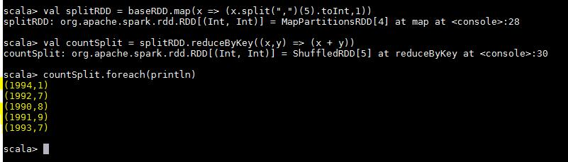
- The total air distance covered by each user per year

Below is the code used:-

- val splitRDD = baseRDD.map(x => ((x.split(",")(0),x.split(",")(5)),x.split(",")(4).toInt))

- val distRDD = splitRDD.reduceByKey((x,y) => (x + y))

- distRDD.foreach(println)

Output:-
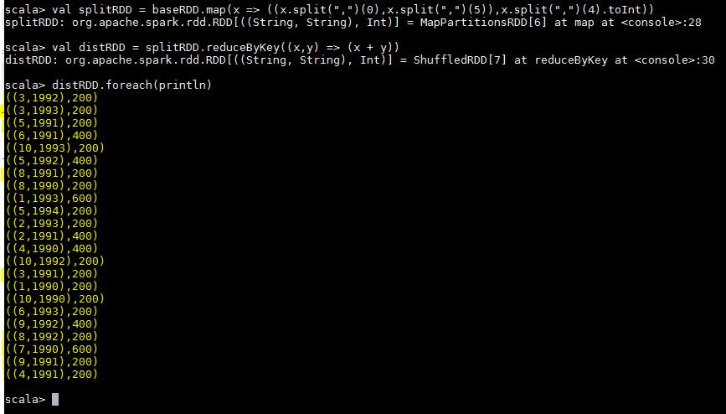
- User has travelled the largest distance till date

Below is the code used:-
- val userRDD = baseRDD.map(x=> (x.split(",")(0),x.split(",")(4).toInt))

- val totaldistRDD = userRDD.reduceByKey((x,y) => (x+y))

- val maxRDD = totaldistRDD.takeOrdered(1)

- maxRDD.foreach(println)

Output:-
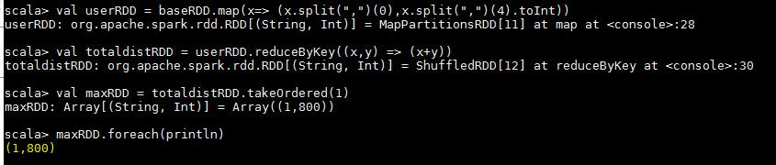

This shows that Mark has travelled the largest distance till date.

- The most preferred destination for all users.

Below is the code used:-
- val destRDD = baseRDD.map(x => (x.split(",")(2),1))

- val destreduceRDD = destRDD.reduceByKey((x,y) => (x + y))

- val maxRDD = destreduceRDD.takeOrdered(1)(Ordering[Int].reverse.on(_._2))

- maxRDD.foreach(println)
Output:-
